ITERACIONES:

1. CPU: 0.2 // MEMORY: 256M

1. CPU: 0.15 // MEMORY: 256M

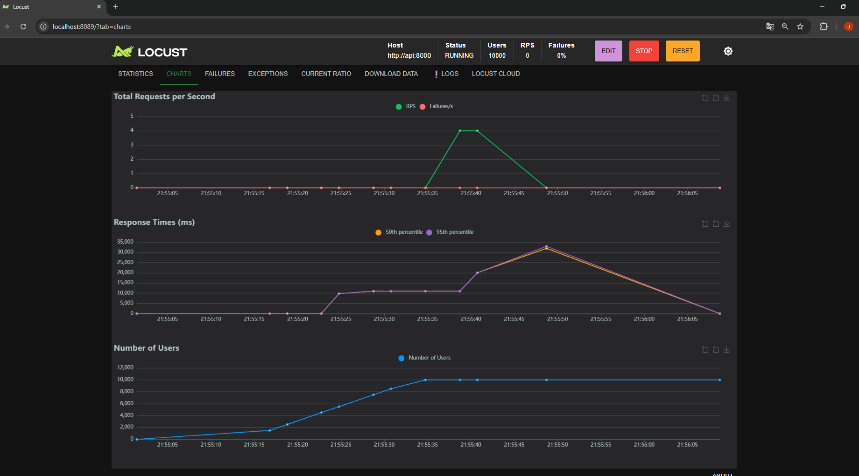

1. CPU: 0.10 // MEMORY: 256M

1. CPU: 0.1 // MEMORY: 200M

1. CPU: 0.1 // MEMORY: 128M

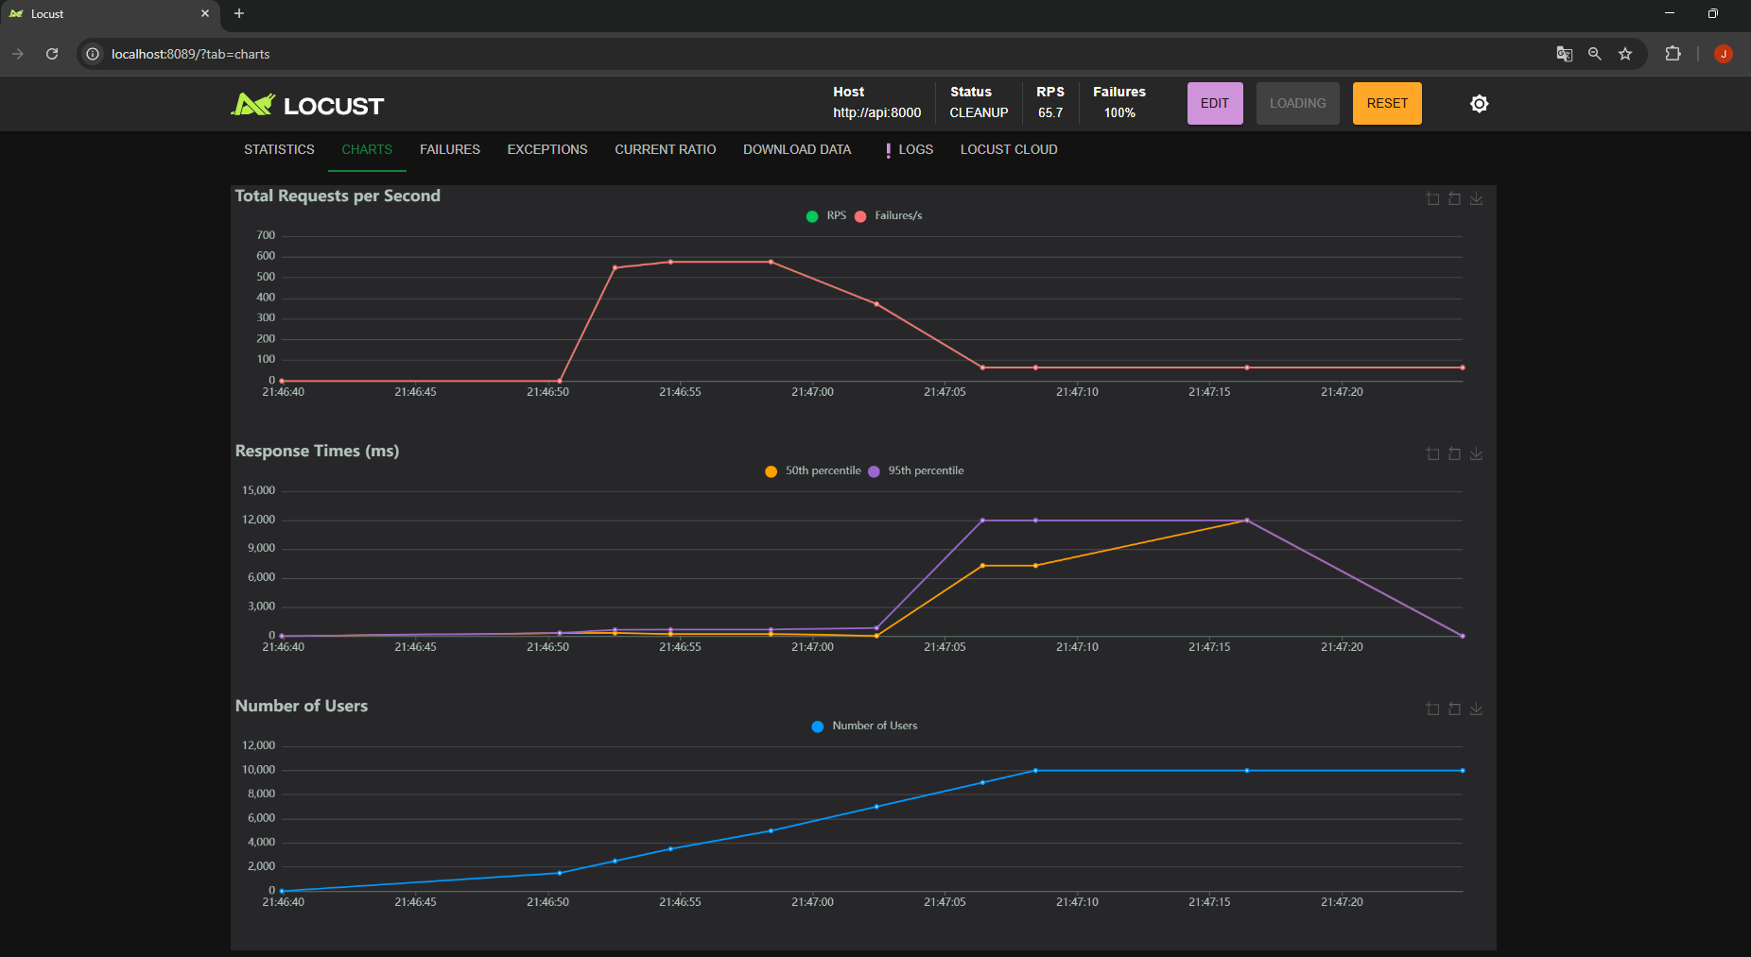

SUMANDO RÉPLICAS:

1. 2 REP // CPU:0.1 // MEMORY: 200M

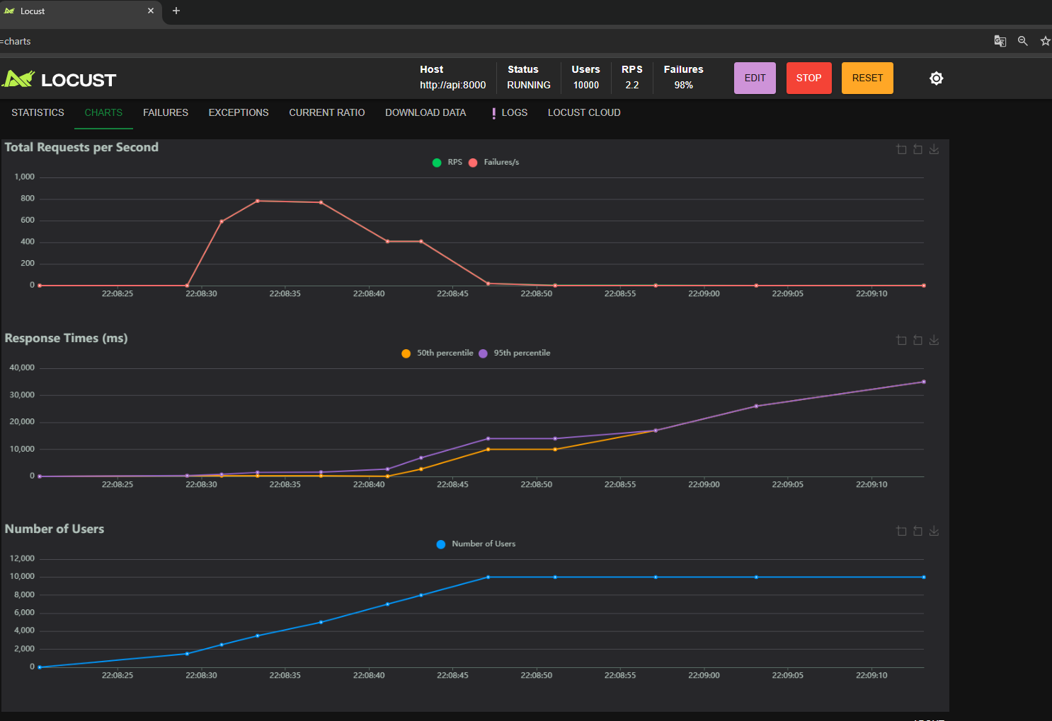

1. 2 REP // CPU: 0.1 // MEMORY 256M

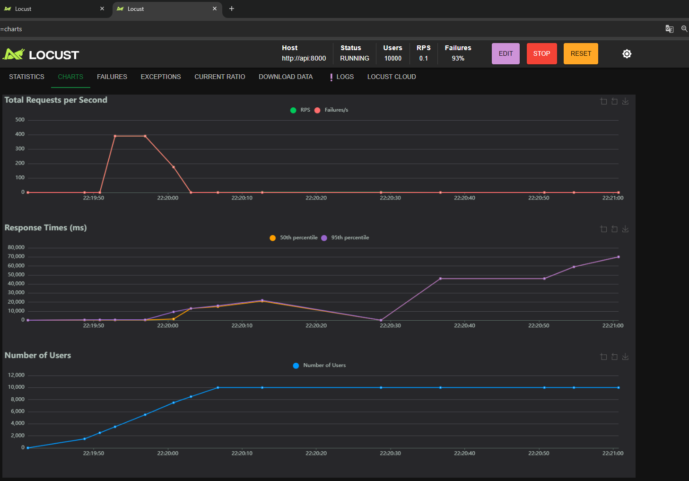

1. 2 REP // CPU: 0.15 // MEMORY: 256M

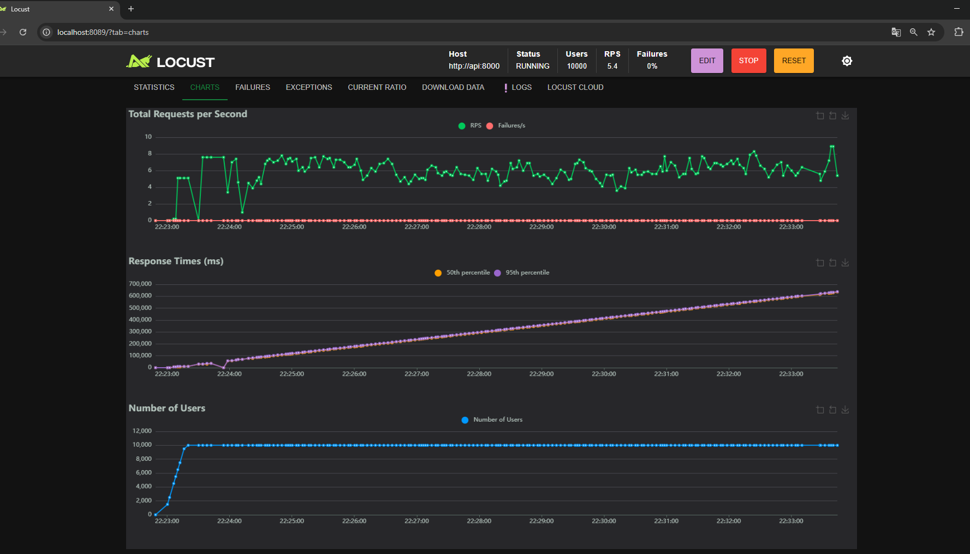

1. 3 REP // CPU: 0.15 // MEMORY: 256M

